A

**Synopsis**

**on**

**School Management System**

**Submitted by**

**Group. No. G-C13**

**Vishal Chaturvedi – 2100290140150**

**Shagun – 2100290140119**

**Vishal Rajput- 2100290140151**



**Under the supervision of Ms. Divya Singhal**

**Department of Computer Applications,**

**KIET Group of Institutions,**

**Delhi-NCR, Ghaziabad**

**September’ 2022**

**Abstract**

School management system is an application developed using java and for backend Firebase is used, by this app students can access the notes uploaded by the teachers.

In this application student can submit their fee using online payment method directly. If the admin of the portal such as teacher, wants to generate report about any student of their class then by just clicking on report button entire report will be generated which will contain the attendance details, academic scores etc.

**INTRODUCTION**

The main objective of “School Management System” is to automate all functionalities of a school. By using this system we can manage all school management work like admission, fees submission, time table management and result declaration.

Data such as notes can be easily accessed by the student and teachers can easily update it using their credentials.

Admin of this portal can create report of any student at any required time.

Students can check their results by logging into the portal, if there is any update for the students then this application will generate a notification by which all students will be updated towards the change.

**Technology /Software Requirements**

* **Operating System**: Window 11
* **Software**: Android Studio
* **Language**: Java
* **Back-end**: Firebase

**Hardware Requirement**

* **Processor:** Ryzen 7
* **Processing speed:** 2 GHz or above
* **Ram:** 4 GB
* **Hard Drive:** 50 GB

**MODULE DESCRIPTION**

* Student/Faculty Login
* Profile
* Study Material
* Announcement
* Meeting Interface
* Payment Interface
* Time table management

**Gantt chart**

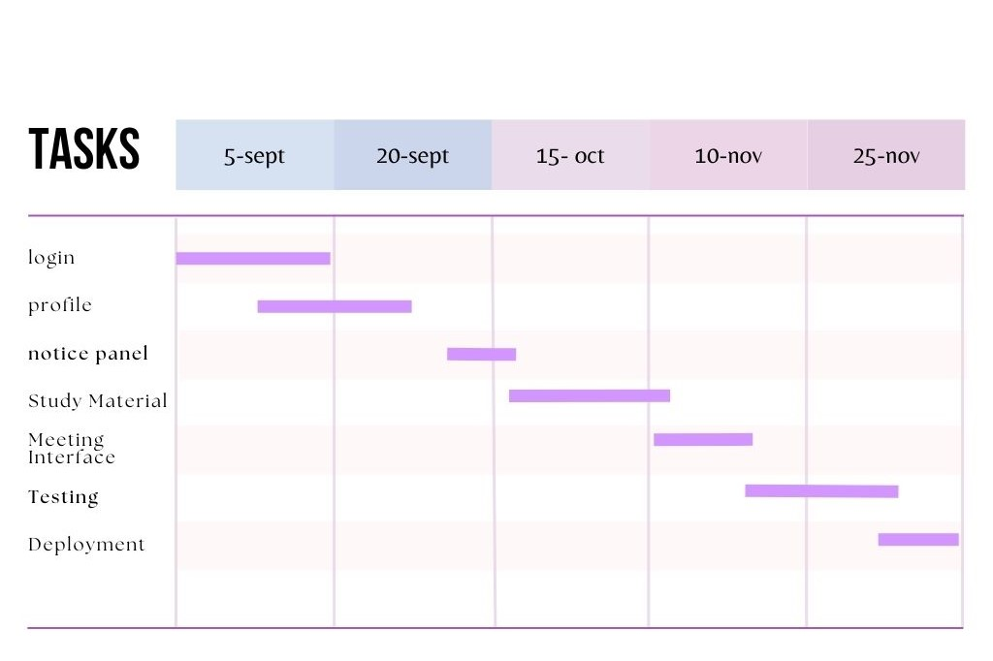

**CONCLUSION**

Application providing on-demand access of notes and other study material for the student, also school’s management can use it for delivering any announcement to the student or faculty, by simply click on one button entire report of a student can be generated by the admin.